ST. XAVIER’S COLLEGE

**(Affiliated to Tribhuvan University)**

Maitighar, Kathmandu



**Computer Graphics Lab Assignment #7**

**Submitted by:**

Sazjan Neupane

013BSCCSIT036

**Submitted to:**

|  |  |
| --- | --- |
| Er. Anil Sah  Lecturer, St. Xavier’s College |  |

**Date of submission:** September 8, 2015

**SOURCE CODE**

//---------------------------------------------------------------------------

#include <vcl\vcl.h>

#pragma hdrstop

#include "Unit1.h"

//---------------------------------------------------------------------------

#pragma resource "*.dfm"

int a, b, i, j, x, y;

TReflect_X *Reflect_X;

//---------------------------------------------------------------------------

__fastcall TReflect_X::TReflect_X(TComponent* Owner)

: TForm(Owner)

{

}

//---------------------------------------------------------------------------

void __fastcall TReflect_X::Reflect_OriginClick(TObject *Sender)

{

{

x = Image1->Height;

y = Image1->Width;

for(i=0;i<=x;i++)

{

for(j=0;j<=y;j++)

{

a = -i;

b = -j;

a=a+x;

b=b+y;

Image2->Canvas->Pixels[a][b] = Image1->Canvas->Pixels[i][j];

}

}

}

//---------------------------------------------------------------------------

}

//---------------------------------------------------------------------------

void __fastcall TReflect_X::Reflect_xClick(TObject *Sender)

{

x = Image1->Height;

y = Image1->Width;

for(i=0;i<=x;i++)

{

for(j=0;j<=y;j++)

{

a = i;

b = -j;

b=b+y;

Image2->Canvas->Pixels[a][b] = Image1->Canvas->Pixels[i][j];

}

}

}

//---------------------------------------------------------------------------

void __fastcall TReflect_X::Reflect_YClick(TObject *Sender)

{

x = Image1->Height;

y = Image1->Width;

for(i=0;i<=x;i++)

{

for(j=0;j<=y;j++)

{

a = -i;

b = j;

a=a+x;

Image2->Canvas->Pixels[a][b] = Image1->Canvas->Pixels[i][j];

}

}

}

//---------------------------------------------------------------------------

**OUTPUT**

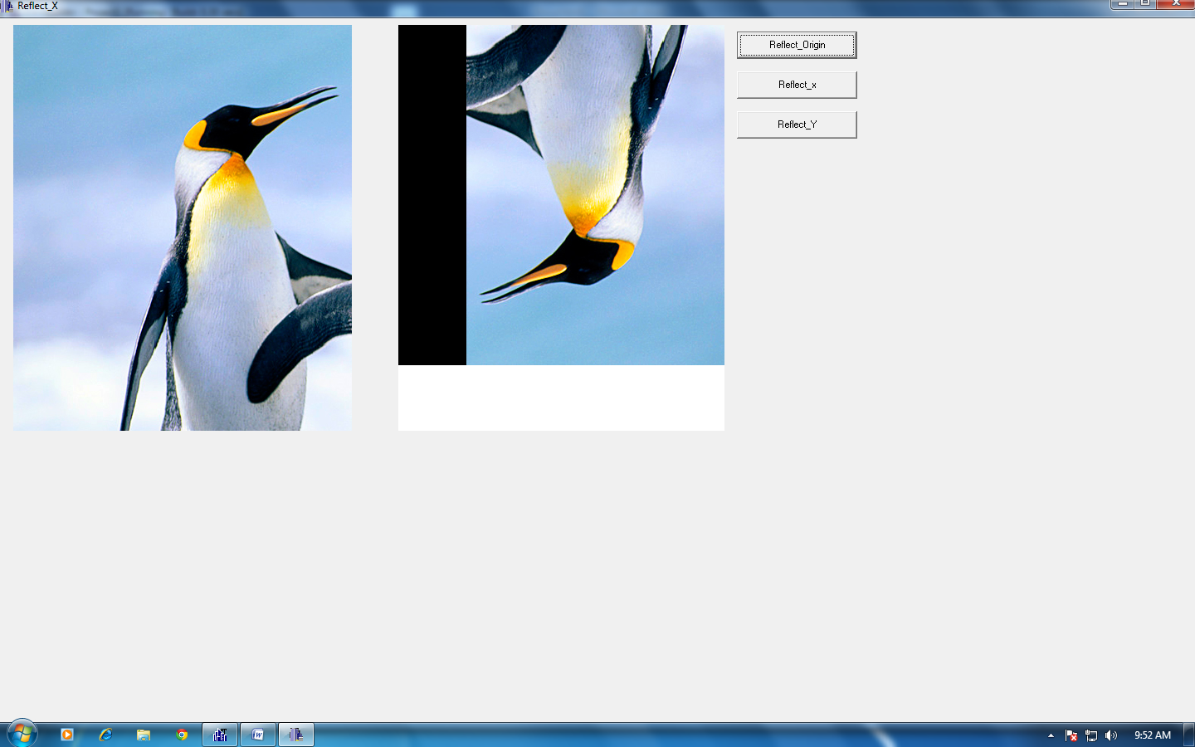

Fig. Reflection about origin.

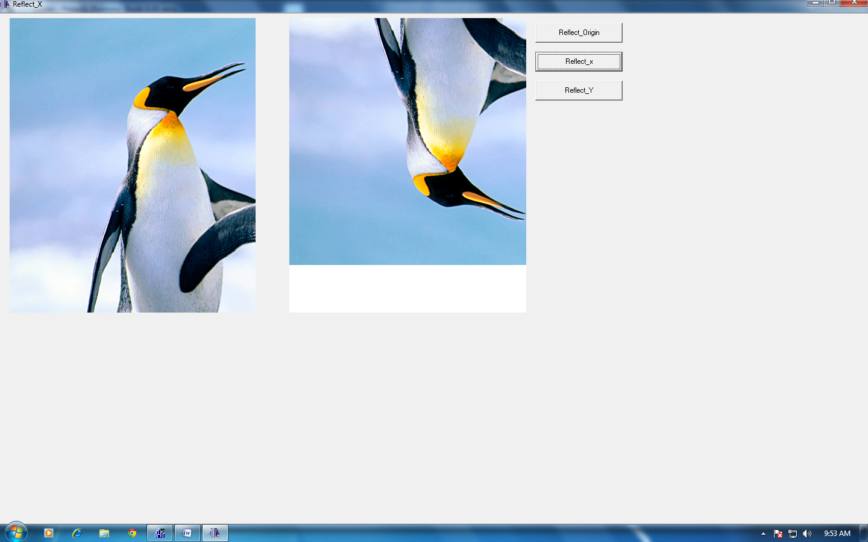

Fig. Reflection about x axis.

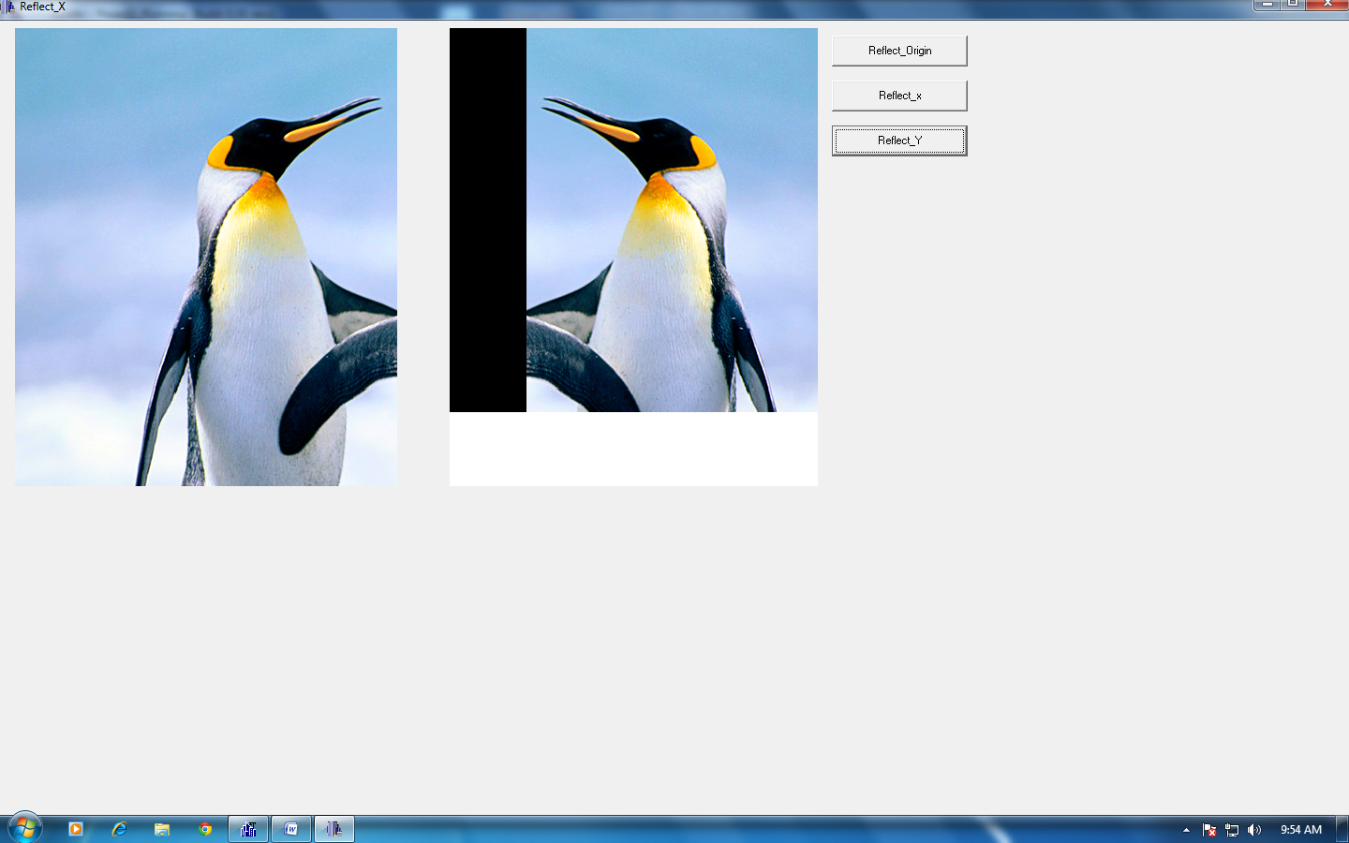

Fig. Reflection about y axis.